H.T No
Regulations:
A18

Sreenidhi Institute of Science and Technology
(An Autonomous Institution)
Code No: 7B723 Date: 17-Jan-2023 (FN)

B.Tech IV-Year I- Semester External Examination, January-2023 (Regular & Supplementary)
ADDITIVE MANUFACTURING PROCESSES (ME)

Time: 3 Hours Max.Marks:70

Note: a) No additional answer sheets will be provided.
b) All sub-parts of a question must be answered at one place only, otherwise it will not be valued.
c) Missing data can be assumed suitably.
Bloom's Cognitive Levels of Learning (BCLL)

Remember | L1 | Apply | L3 | Evaluate | L5
Understand | L2 | Analyze | L4 | Create | L6

Part - A Max.Marks:20

Answer all QUESTIONS.
 |  | BCLL | CO(s) | Marks
1 | What is the need of prototype in product development? | L2 | CO1 | [2M]
2 | Define the term ‘photopolymer’. Give some examples. | L2 | CO2 | [2M]
3 | What are the advantages of powder based AM processes? | L1 | CO3 | [2M]
4 | What is the basic difference between CAD file and stl file? | L1 | CO4 | [2M]
5 | What is a CMM? Where is it used? | L1 | CO5 | [2M]
6 | Give the applications of FDM and SLA processes. | L2 | CO6 | [2M]
7 | How are wireframe model and surface model different to solid model? | L2 | CO1 | [2M]
8 | What is the function of supports in 3D printing? | L2 | CO2 | [2M]
9 | What are the disadvantages of STL format? | L2 | CO4 | [2M]
10 | Why is FDM a popular AM process? | L2 | CO2 | [2M]

Part – B Max.Marks:50
ANSWER ANY FIVE QUESTIONS. EACH QUESTION CARRIES 10 MARKS.

 |  |  | BCLL | CO(s) | Marks
11. | a) | Describe the five sequential steps in a general AM process chain. | L2 | CO1 | [5M]
 | b) | Classify the AM processes based on the various criteria. | L3 | CO1 | [5M]
12. | a) | Describe Stereo lithography with neat diagram and mention its advantages, and applications. | L3 | CO2 | [5M]
 | b) | Discuss the phenomenon of photo polymerization. | L3 | CO2 | [5M]
13. |  | A prototype of a part is to be fabricated using stereolithography. The part is shaped like a right triangle whose base = 40 mm, height = 50 mm, and thickness = 20 mm. In application, the part will stand on its base, which is 40 mm by 20 mm. In the stereolithography process, the layer thickness = 0.50 mm. The diameter of the laser beam (“spot size”) = 0.10 mm, and the beam is moved across the surface of the photopolymer at a velocity of 300 mm/s. Compute the minimum possible time required to build the part, if 9 sec are lost each layer to lower the height of the  platform that holds the part. Neglect the time for post curing. | L4 | CO3 | [10M]
14. | a) | Elaborate the differences between ASCII and Binary coded formats of STL file. | L4 | CO4 | [5M]
 | b) | Write the ASCII stl code for the following shaded triangle  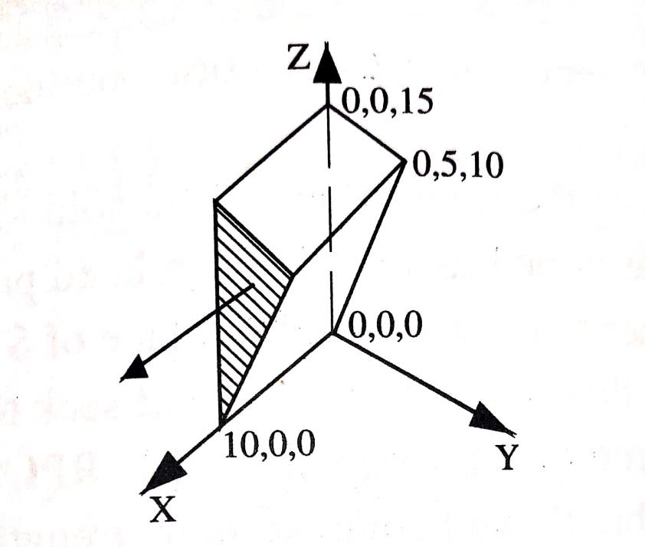 | L4 | CO4 | [5M]
15. | a) | Compare Conventional tooling with rapid tooling wrt speed, cost and quality. | L3 | CO5 | [5M]
 | b) | Explain the principle of silicone rubber molding process. | L2 | CO5 | [5M]
16. | a) | Summarize the design area applications of AM processes. | L2 | CO6 | [5M]
 | b) | In the Automotive domain, identify the applications of AM processes. | L3 | CO6 | [5M]
17. | a) | Differentiate between additive, subtractive and forming manufacturing processes. | L3 | CO1 | [4M]
 | b) | Outline the principle of LOM process. | L4 | CO2 | [3M]
 | c) | How is Built time calculation done for a AM part? | L2 | CO3 | [3M]
18. | a) | Explain the errors in a STL file format. | L2 | CO4 | [4M]
 | b) | What are the purposes of using CMMs? | L2 | CO5 | [3M]
 | c) | Give some applications of AM processes in Medical & bio technology industry. | L3 | CO6 | [3M]

-- 00 -- 00 –

